**PROJECT REPORT**

**“**Design and implement a smart, automated system for product labelling and traceability**”**

Submitted By:

Ayush Chandra. Reg no. 220906300

Dalvi Aarya Ujjwal. Roll: 220906

**Under The Guidance Of:**

Dr. Vinay Kr. Jadoun

Department of

Electrical & Electronics   
Engineering

**July, 2025**



**Manipal Institute Of Technology**

**Manipal,**

**576104, Karnataka, India**

**CONTENTS**

|  |  |  |
| --- | --- | --- |
| **No.** | **Topics** | **Page** |
| 1. | Introduction | 3 |
| 2. | Software Requirements and Specifications | 4 |
| 3. | Methodology | 8 |
| 4. | Comparison | 16 |
| 7. | Contribution | 17 |
| 8. | Conclusion | 17 |
| 9. | References | 18 |

1. **INTRODUCTON**

Our project has taken the company Patanjali Ayurved, the project is based on software coded in MATLAB software. The software first initiates data on the toothpaste, soap, shampoo with EAN-13 barcode labels for each product manufactured, 150 in total consisting of 3 batches (50 in each batch). The 150 products have some defective products as well and this defective handful of products are detected later using Machine Learning methods such as the Interquartile Range (IQR) method and the Z-score method. It processes the data from the Excel file.

**2. SOFTWARE REQUIREMENTS AND SPECIFICATIONS**

**2.1 Product Perspective**

The objective of this project is to develop an effective way to create and store barcodes for different types of products for the given company. along with machine learning tools for finding the defective products. In today’s competitive landscape, reducing system overhead and customer costs is crucial for market sustainability. This project was made using MATLAB (2025a) software.

**2.2 User Characteristics**

The users who are developing this whole project or are trying to make an upgrade of the given project and the algorithms implemented need to be proficient in the following areas :

* MATLAB programming.
* Machine Learning ( Interquartile Range (IQR) method and the Z-score method )
  1. **Specific Requirements**

The whole of this project work was developed using the MATLAB software which and the basic concepts of IQR and Z-score of machine learning. So the specific requirements for this project work are :

* MATLAB software .
* Microsoft Excel.
* Windows 11 or any compatible Operating Systems.

**Problem Definition:**

There is a demand of making barcodes for products and analysing their quality, finding out the defective products and at the company (Patanjali), the demand is 150 in number and there are 3 different types of products : shampoo, soap and toothpaste.

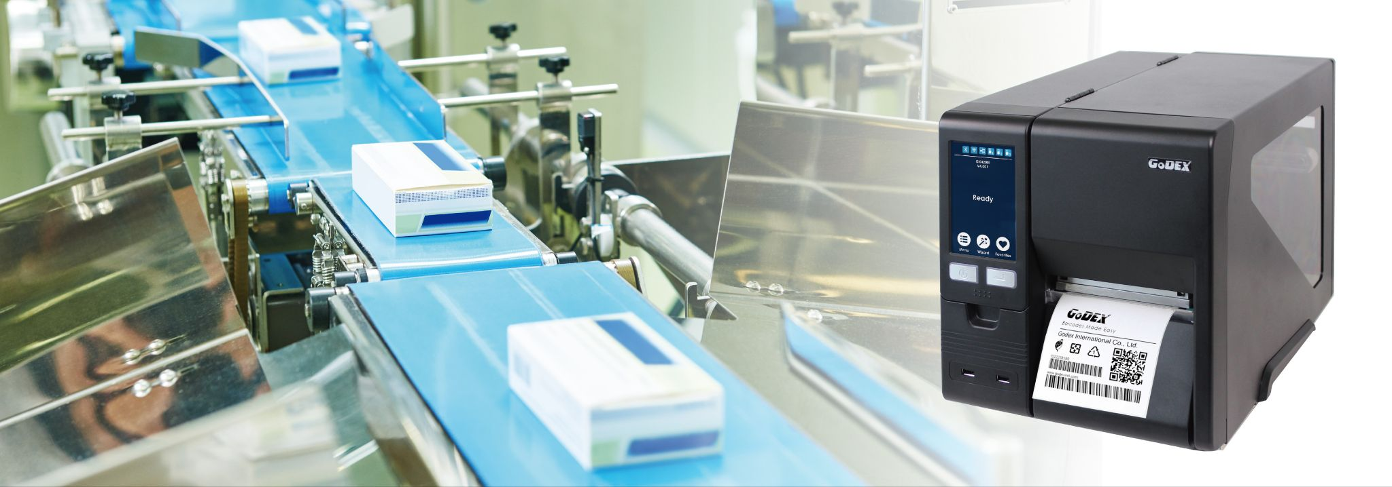

**Fig 1** : Representative image of labelling the products with barcode

* 1. **Interquartile Range (IQR) method**

We use Interquartile Range (IQR) technique where the outliers are to be found from continually distributed data [2]. The difference between first and third quartile is taken : -

**IQR = Q3 − Q1**

This IQR is called as the midspread or middle 50% or H-spread. IQR can be utilized to divide the points of 25% and to build boxplot, which is IQR’s graphical representation. In this method the dataset is divided into quartiles and orders the dataset into four equal parts : Q1, Q2, Q3 & Q4.

(following algorithm is directly taken from [2])  **1.2.1 Algorithm Steps:**

(1) Median is used to the calculate quartiles recursively.

(2) If 2n is the even number of entries

Then,

Q1 is the first quartile = smallest entry median

Q3 is the third quartile = largest entry median,

(3) If 2n + 1 is the odd number of entries

Then,

Q1 is the first quartile = smallest entry median

Q3 is the third quartile = largest entry median,

(4) Q2 is second quartile an ordinary median.

* 1. **Z-score method**

In Z - score method [3], we represent the abnormal behavior items in terms of its association with standard deviation and mean of the collection of arguments. Estimation of Z-score is just the scattering diagram plotting of items, setting the value of its standard deviation and mean as 0 & 1 respectively. Z-score’s objective is the elimination of the properties of position and scale of the data point.

In the scattering diagram, the items that are very deviated from 0 value is considered as anomaly.

Following algorithm steps are taken from [3] directly: -

(1) Null Hypothesis: There is no significance discrepancy between the standard deviation and mean of data items

H0: μ1=μ2

(2)Step 2: Alternative Hypothesis: There is significance discrepancy between the standard deviation and mean of data items.≠

H1: μ1≠μ2

(3) Level of significance: The level of significance is denoted with

α =0.001 (or) α =0.005

(4) Test Statistics: The test statistics for outlier detection is given by

Z= $\frac{x-μ}{σ\sqrt{\frac{1}{n}}}$

(5) Critical Region: At position, we are determining

whether data points are outliers are there or not using a preset boundary.

**3.Methodology**

1. **Generating barcodes for products.**

Matlab code is written and this code simulates the production and quality control process for three types of products—soap, shampoo, and toothpaste—across three batches, each containing 50 items (total: 150 products). It generates unique EAN-13 barcodes, assigns manufacturing dates, records batch numbers, and simulates quality measurements, deliberately introducing a small number of defective items for each product type.

**Figure 2**: Barcodes generated in the excel sheet 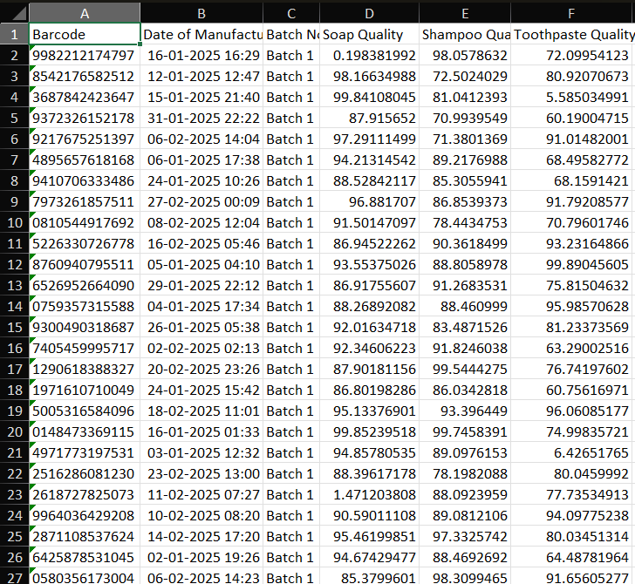

**Figure 3**: Generating Barcode for Each Product

**Figure 4**: Saving all generated barcodes

**2)**Using Z-Score method and IQR method.

This MATLAB code analyses test data for anomalies using two statistical methods: the Interquartile Range (IQR) method and the Z-score method. It processes data from an Excel file, comparing each test value to thresholds derived from training data, and flags values that are considered outliers. So, by using both these methods we can find the outliers and determine products whose qualities are not up to the mark.

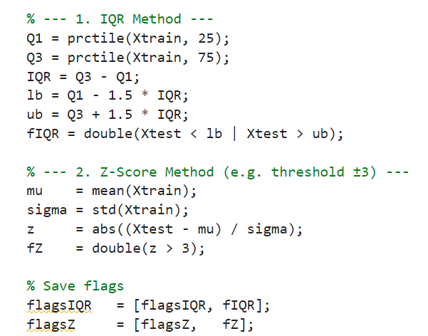

**Figure 5**: IQR and Z-Score method MATLAB Script

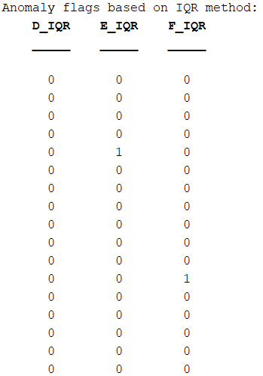

**Figure 6**: IQR Method Anomaly Flag Raise

**Figure 7**: Z-Score Method Anomaly Flag Raise

**3.Traceability**

MATLAB script performs automatic decoding of an EAN-13 barcode from an image file. It processes the image, extracts the barcode bits, and decodes them into the corresponding 13-digit EAN-13 number.

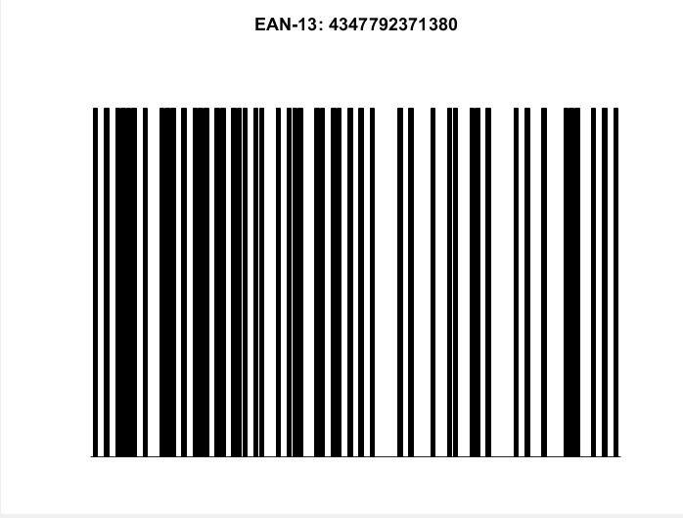

**Figure 8**: Taking Barcode Input

**Figure 9**: Bit Extraction from rescaled Barcode

**Figure 10**: Final Output

|  |  |
| --- | --- |
| **Comparison between the methods** | |
| **Method** | **ERROR %** |
| IQR method | 0% |
| Z-score method | 0% |

|  |  |
| --- | --- |
| **Individual Contributions** | |
| Ayush Chandra | Barcode generation and IQR part |
| Daalvi Aarya | Traceability and Z-score method part |

**4. CONCLUSION**

The project demonstrated a smart and automated system for product labelling and traceability using MATLAB. By integrating barcode generation, defect detection using statistical anomaly detection techniques (IQR and Z-Score methods), and barcode decoding for traceability, the system achieved a complete cycle of manufacturing support and quality control. The implementation focused on three product types—soap, shampoo, and toothpaste—across multiple batches, with defects being intentionally introduced to test the robustness of the detection algorithms.

The use of machine learning-based statistical techniques helped in identifying outliers with high accuracy (0% error for both the methods), ensuring that defective products can be filtered efficiently before reaching the customer. Moreover, the ability to decode and verify product information using EAN-13 barcodes enhances traceability, which is crucial for inventory management and product recalls.

This system, while tailored for Patanjali Ayurved, can be scaled and adapted for use in other manufacturing environments. Future improvements can include real-time scanning integration, automated decision-making based on anomaly severity, and cloud-based database connectivity for enhanced product tracking.

**9. REFERENCES**

**[1]** Figure 1: <https://mustekindia.com/godex-homepage/>

**[2]** Vinutha, H.P., Poornima, B., Sagar, B.M. (2018). Detection of Outliers Using Interquartile Range Technique from Intrusion Dataset. In: Satapathy, S., Tavares, J., Bhateja, V., Mohanty, J. (eds) Information and Decision Sciences. Advances in Intelligent Systems and Computing, vol 701. Springer, Singapore. https://doi.org/10.1007/978-981-10-7563-6_53

**[3]** Venkataanusha, Peruri & Anuradha, Ch & Murty, Dr & Chebrolu, Surya. (2019). Detecting Outliers in High Dimensional Data Sets Using Z-Score Methodology. International Journal of Innovative Technology and Exploring Engineering. 9. 48-53. 10.35940/ijitee.A3910.119119.